**React Frontend Application Deployment Manual**

**Note:** It is to be noted that the AWS S3 bucket / AWS CloudFront distribution was created using a free tier account.

Our team has used AWS S3 with AWS Cloud front to help ensure a faster response for the users when they request content by caching the content in Edge Locations that is performed by the AWS CloudFront service. [1]

This method doesn’t include steps to set up a CI/CD pipeline. The user will have to manually upload the recent build when new changes are made to the codebase.

**AWS S3**

**S3 set up**

Click on Create Bucket



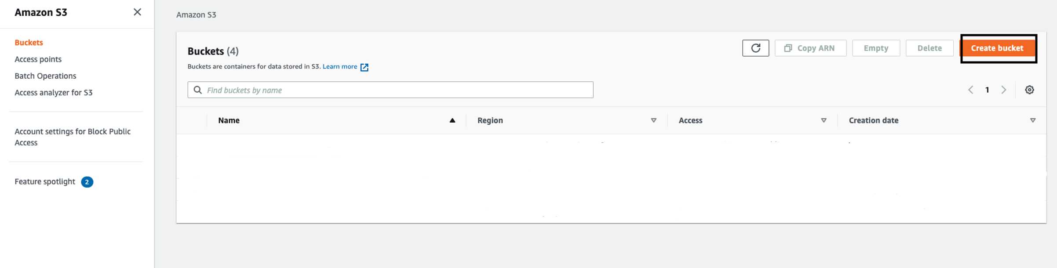

Provide a bucket name in the “Bucket Name” field.   
Using the drop-down menu for “Region”, select Asia Pacific (Sydney) ap-southeast-2

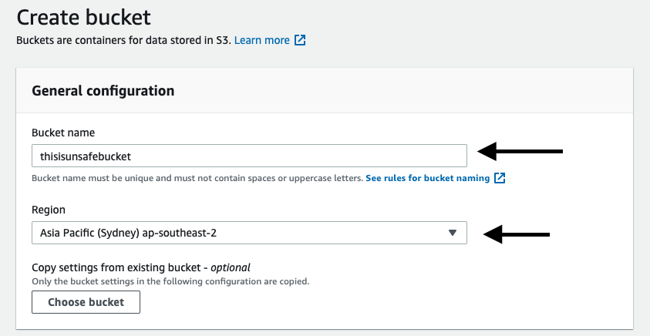

Leave the “bucket settings” to default settings

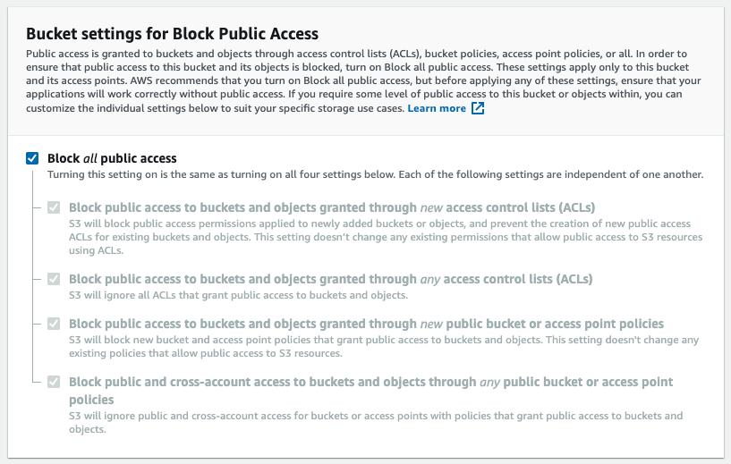

Select Disablefor “Bucket Versioning”

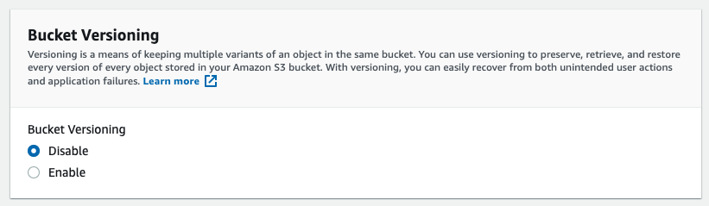

Select Disable for “Default Encryption” and “Advanced Settings”.

Finally, click on the create bucket button.

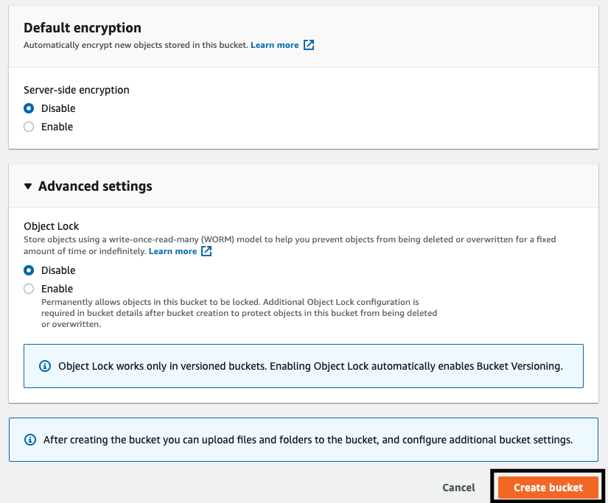

Once the bucket has been created, it would be displayed on S3 dashboard page.

Click the name of the S3 bucket thereafter to be redirected to the bucket overview page.

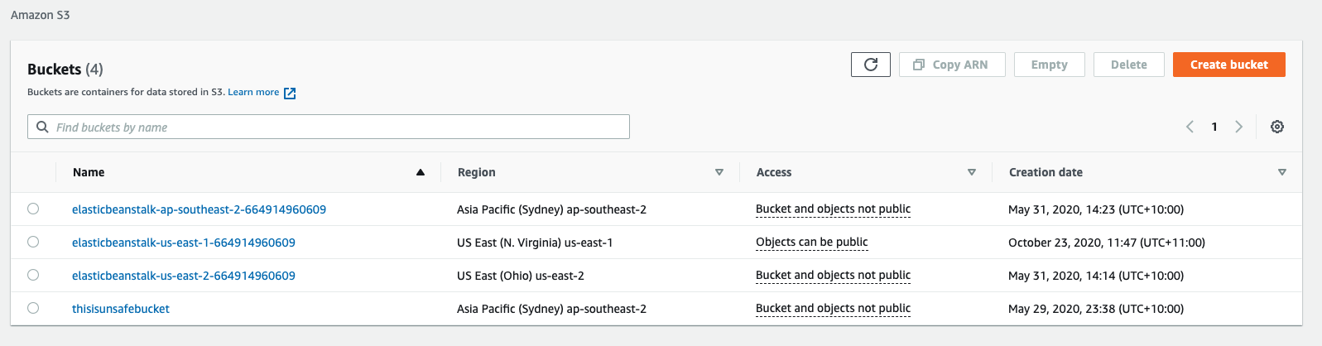 

Click on Permissions

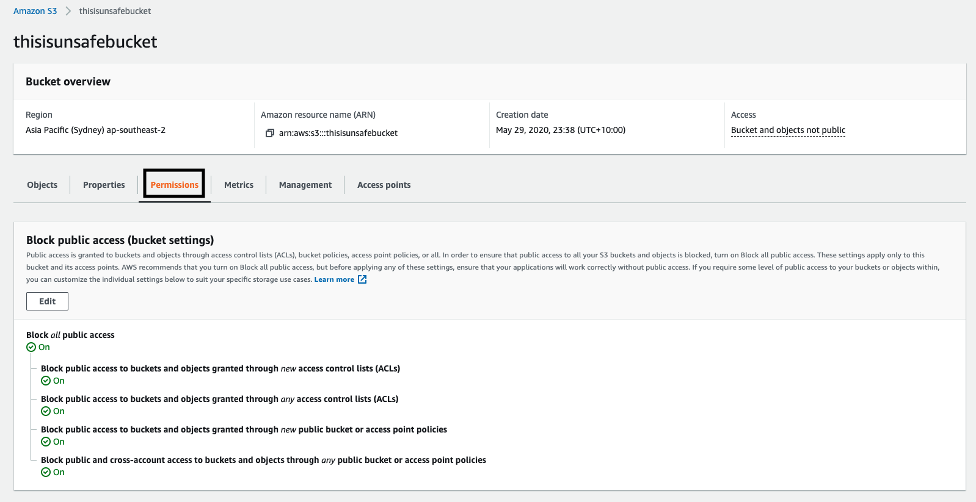

Click on Edit Access Control under the Permissions Tab.

Ensure that the all the checkboxes for “Grantee” has been ticked, and finally save changes.

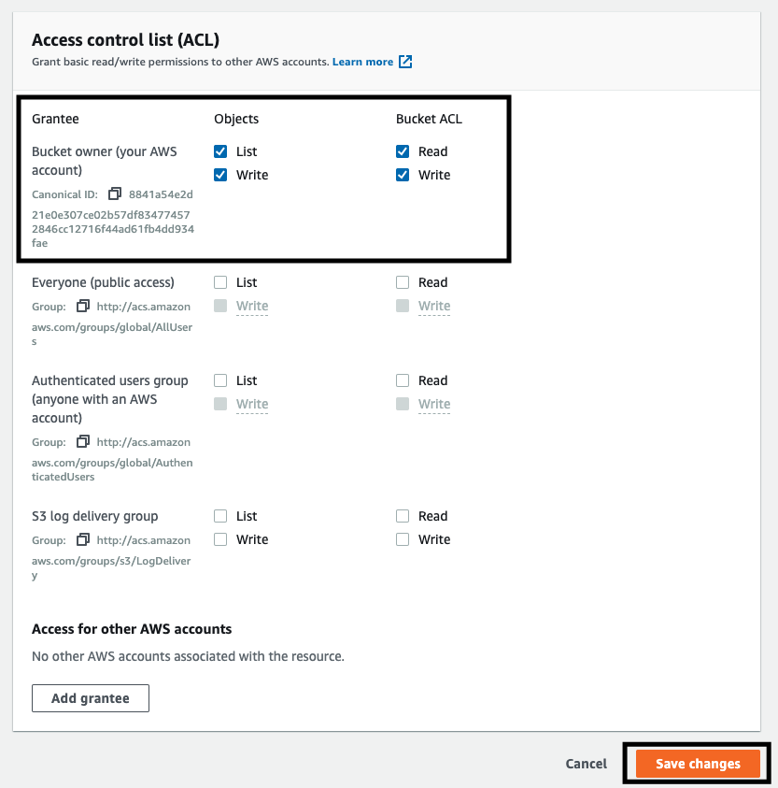

**Deploy front end application**

To build the front-end app for production, run ‘npm run build’ on terminal in the project directory.

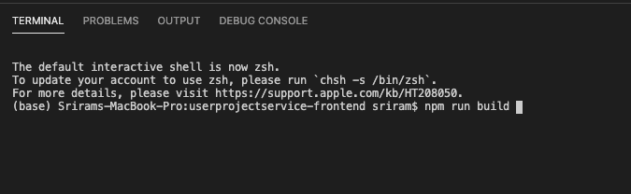

Now, on the AWS bucket Overview page, click on the objects tab, and thereafter click on the upload button

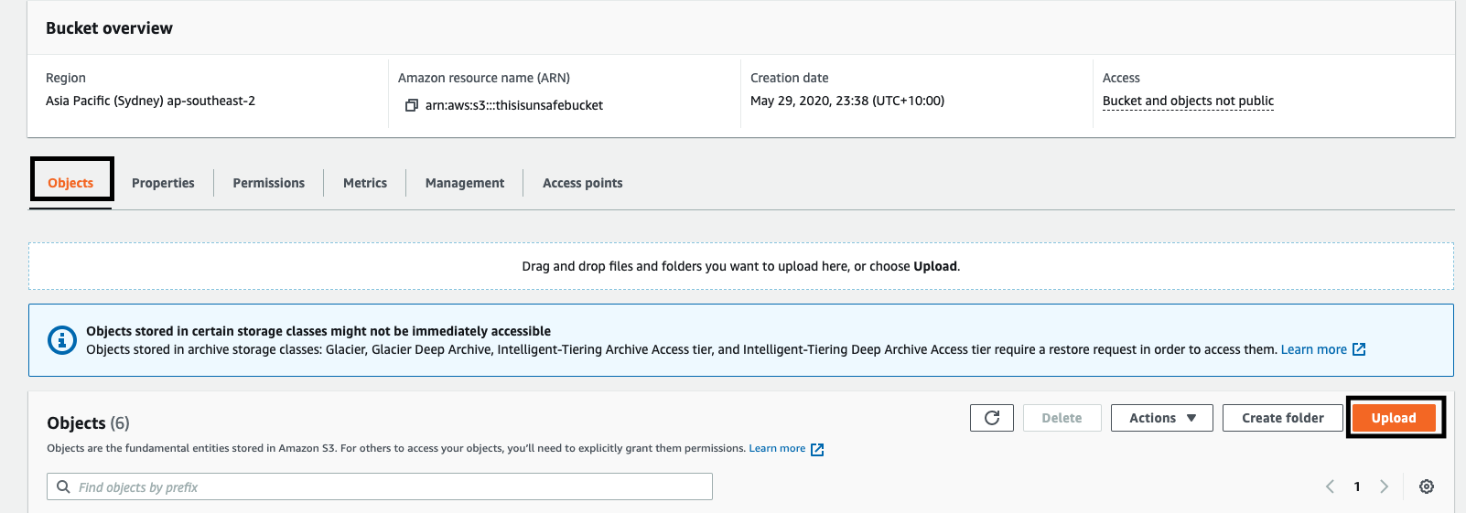

Click on Add Files

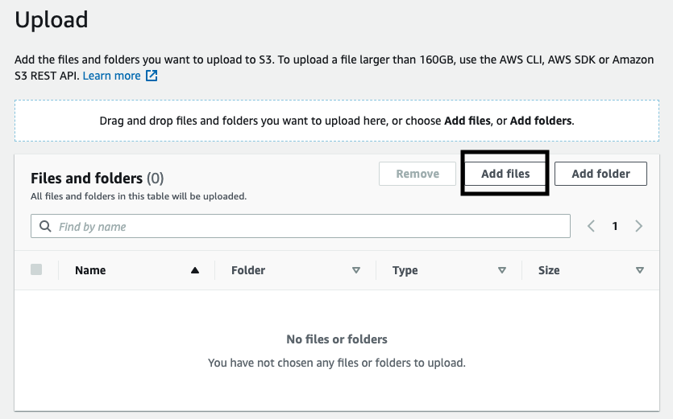

Upload all the files in the build folder which can be located in “userprojectservice-frontend/build”

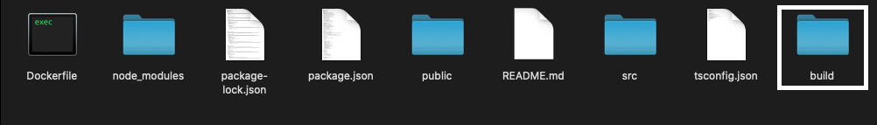

After the files have been uploaded, click on upload

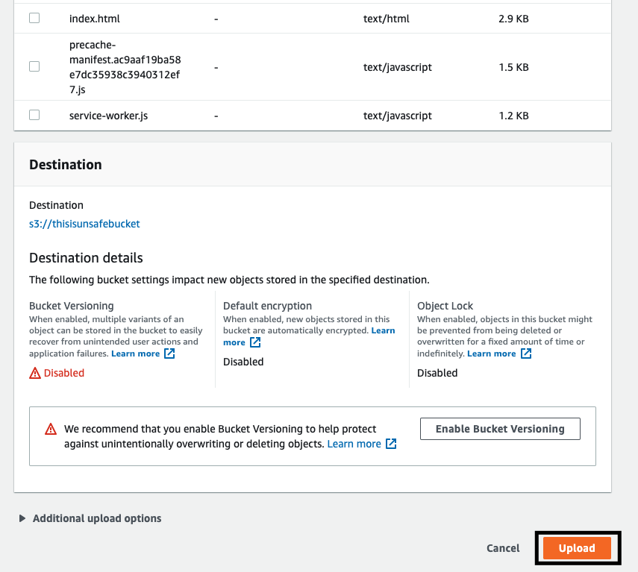

**AWS Cloud Front**

Click the “Create Distribution” button.

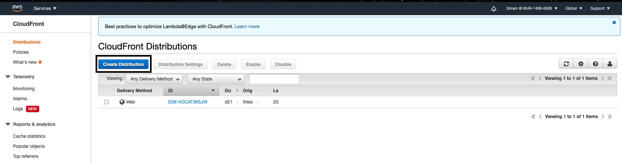



Click “Get Started” for the Web component

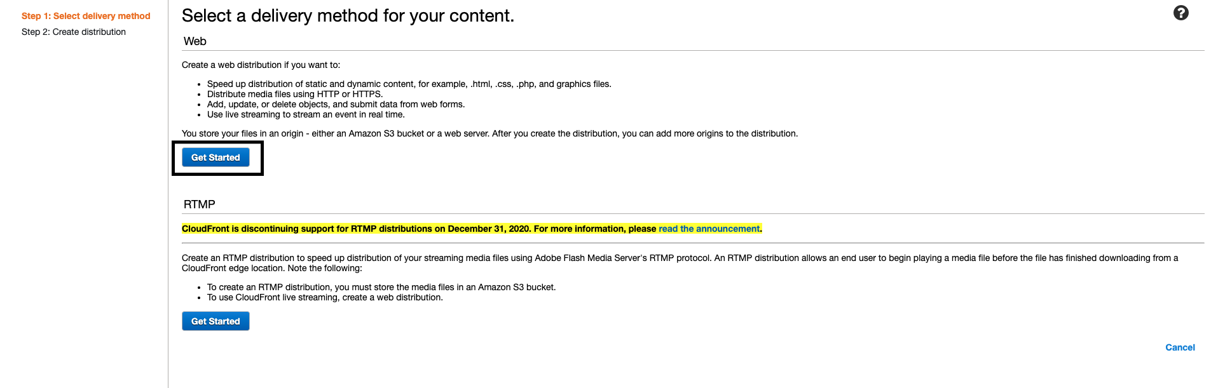

Specify the S3 bucket name in the Origin Domain Name.

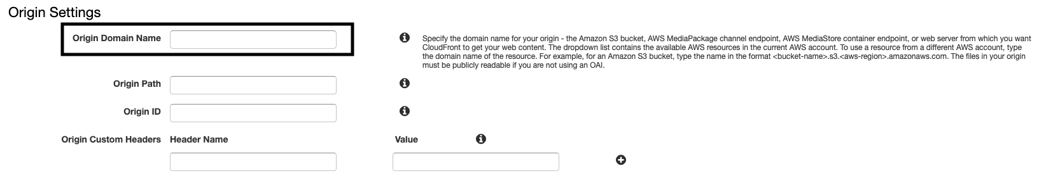

Select “Get, Head, Options, Put, Post, Patch, Delete” under the Allowed HTTP Methods, and leave all the other settings to default.

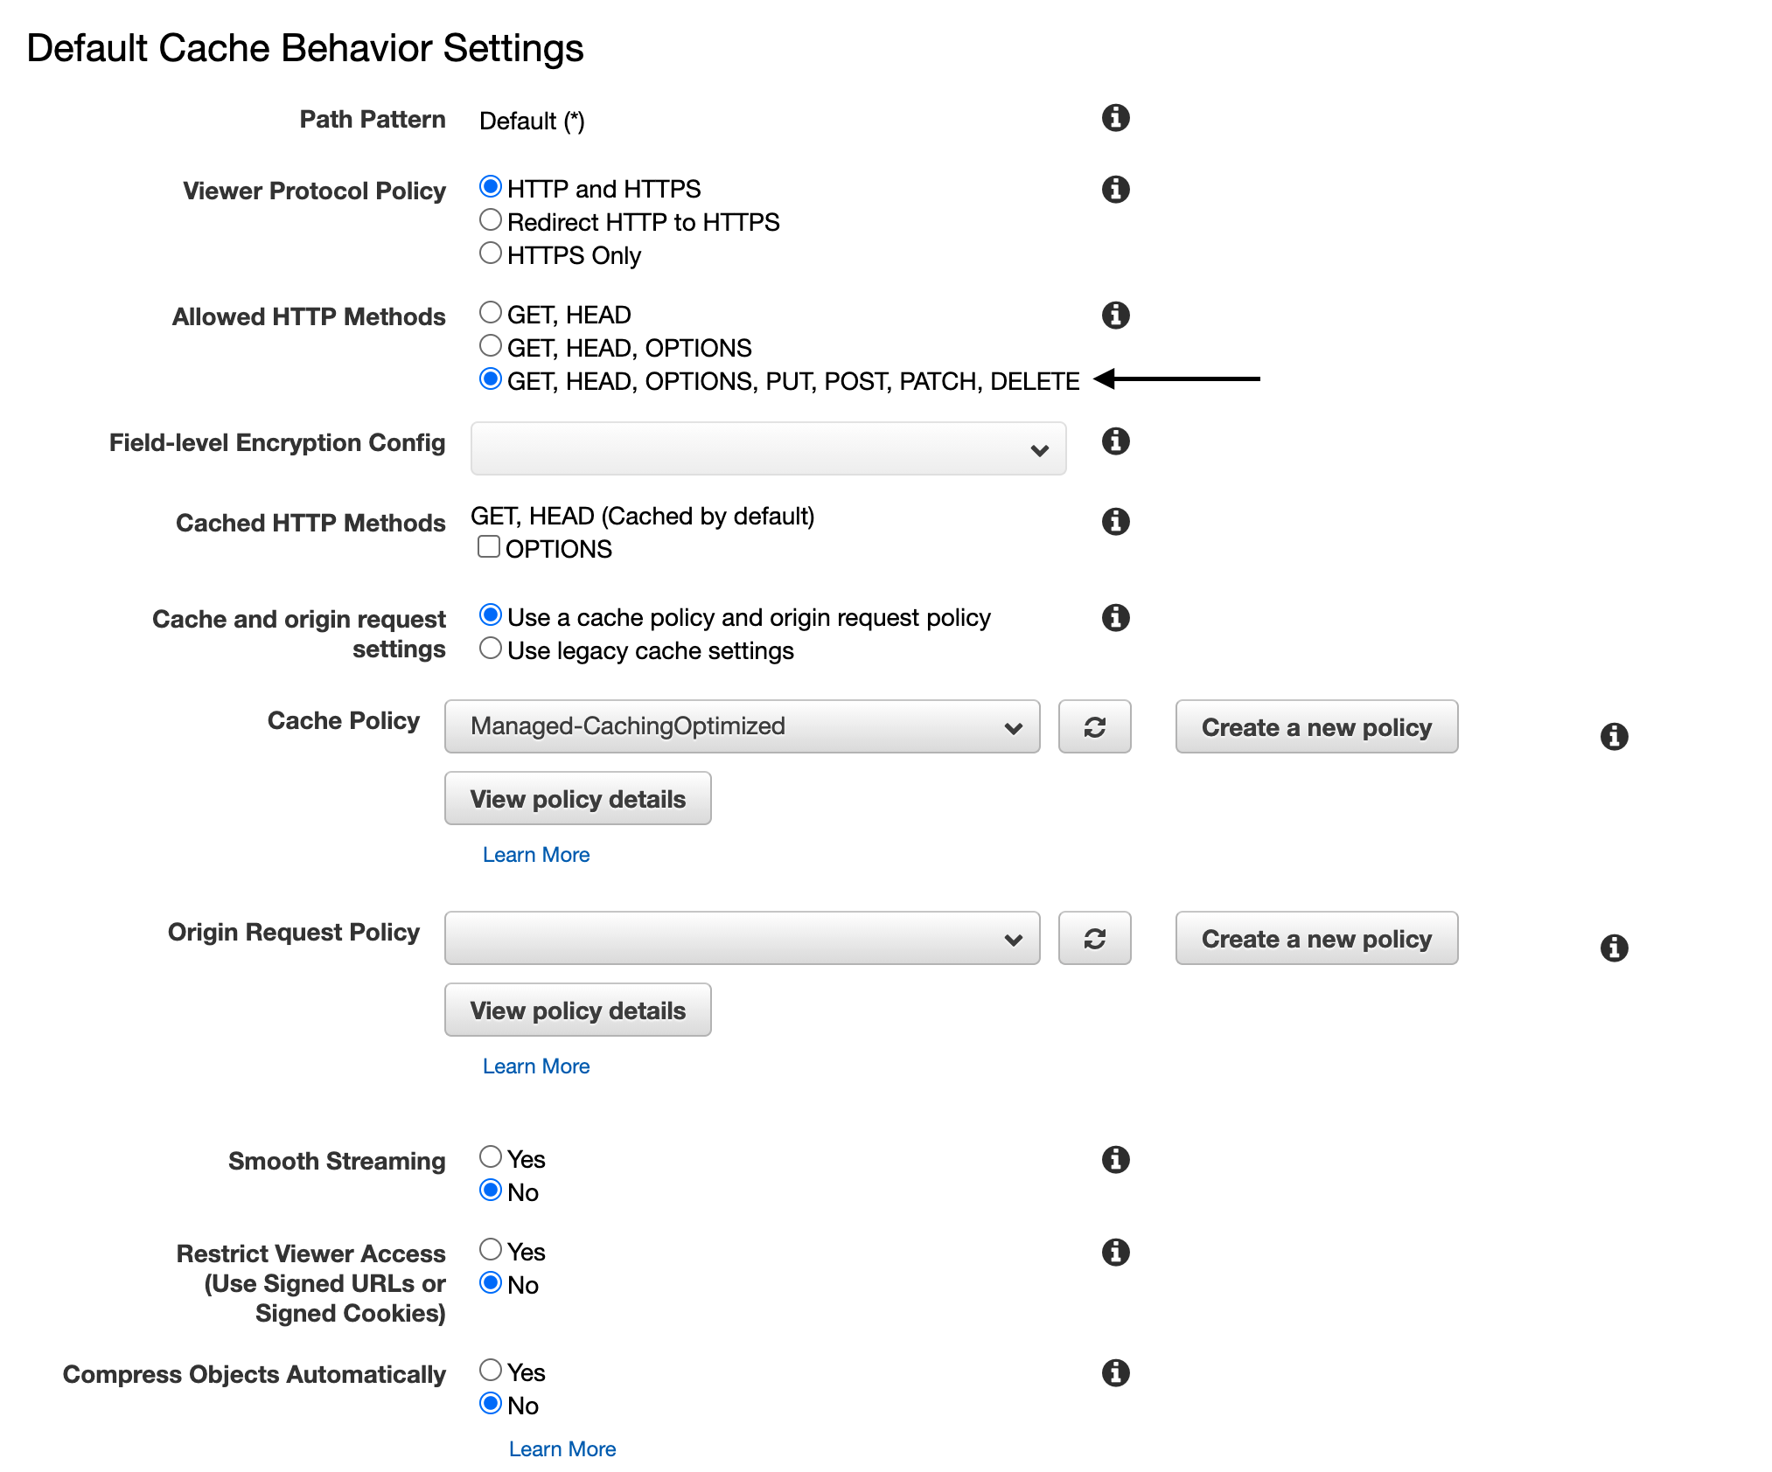

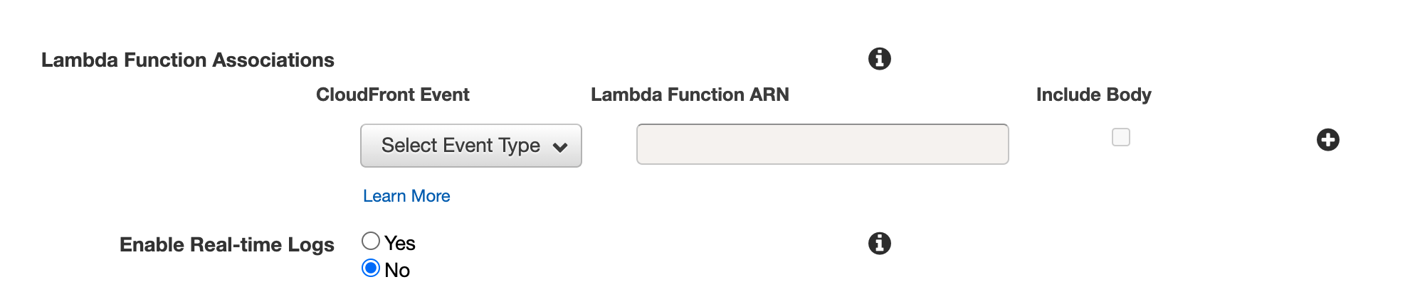

Select “Use US, Canada, Europe, Asia, Middle East and Africa” for the price class option.

Specify the “root file” in the default Root Object. For example, index.html

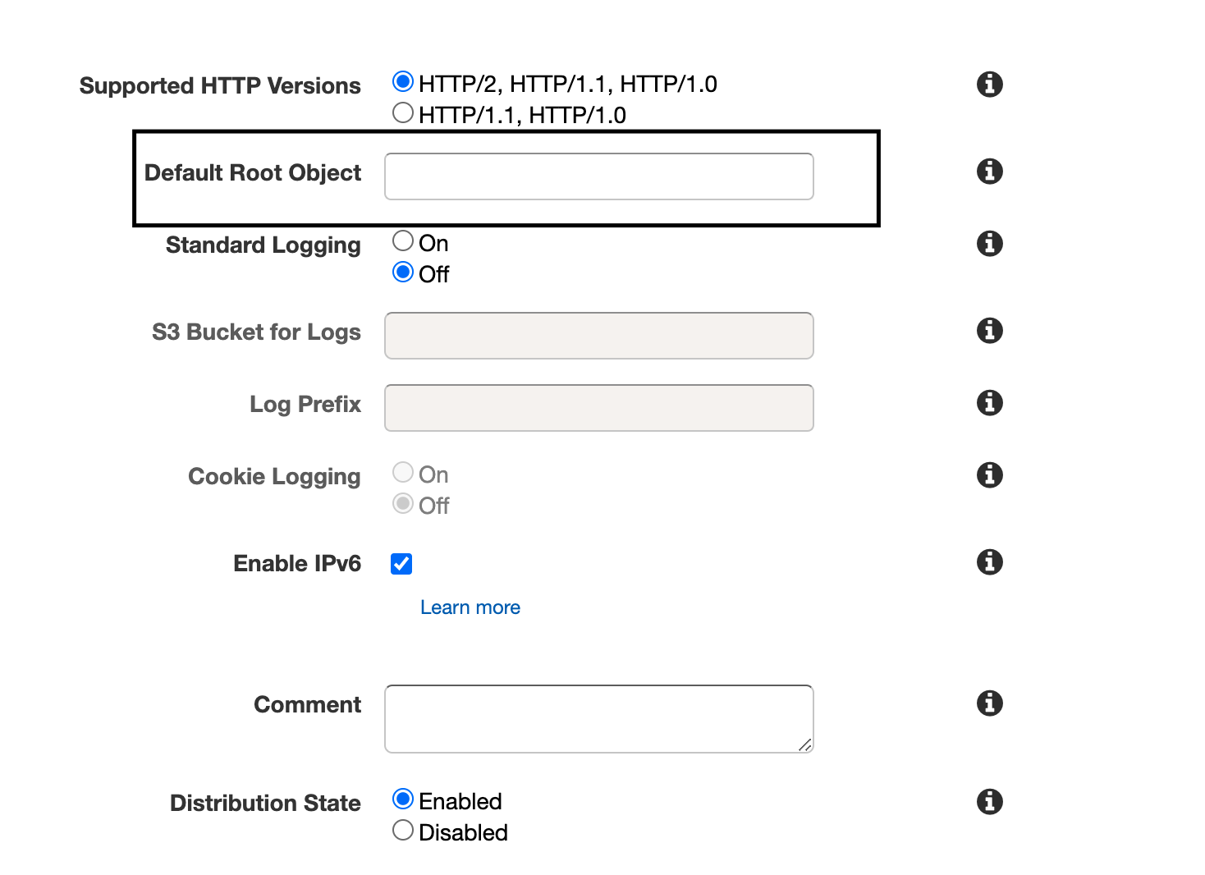

Finally, click Create Distribution



Once the distribution has been created, it could be found on CloudFront Distributions Page.

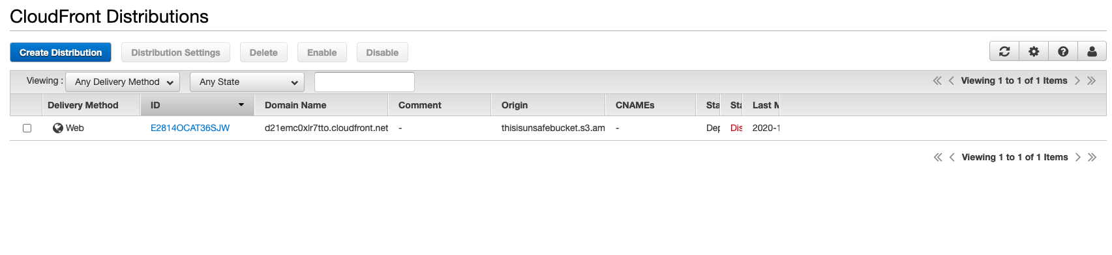

Click on the distribution ID

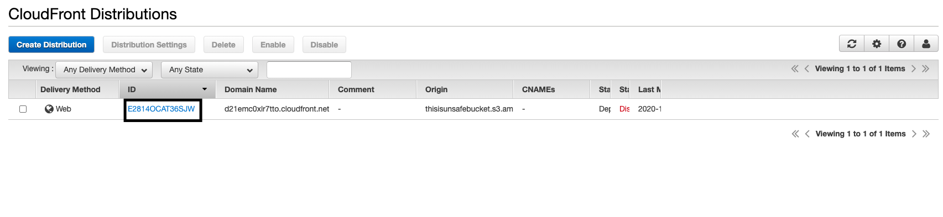

Select the Origin and Origin Groups tab and Click on the Create Origin button

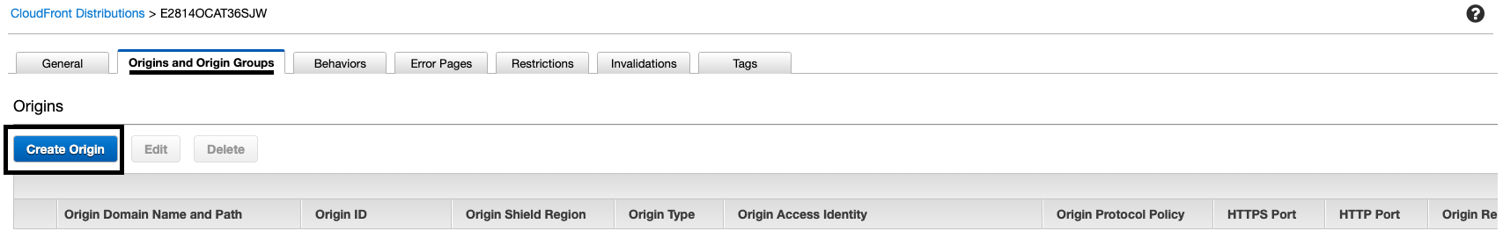

Enter the Origin Domain Name in the “Origin Domain Name” using the following format: *<bucket-name>.s3.<aws-region>.amazonaws.com*

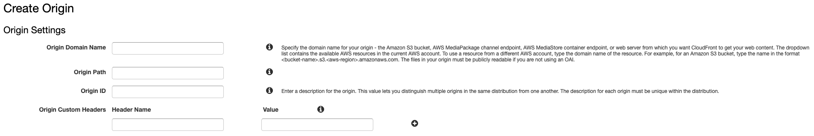

Add the following Header Name and Value into the Origin Custom Headers and click the Create button.

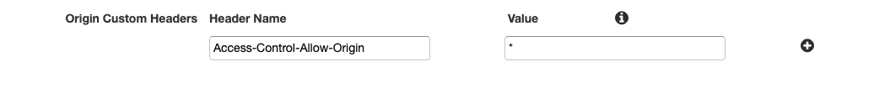

Select the created Origin and click the edit button

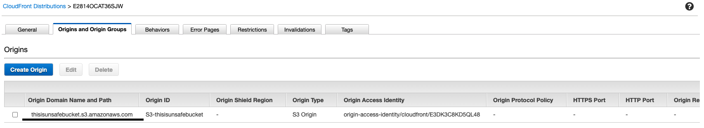

Click Yes, Update Bucket Policy for “Grant Read Permissions on Bucket”

Update the Origin Connection Attempts and Origin Connection Timeout as shown in the figure below.

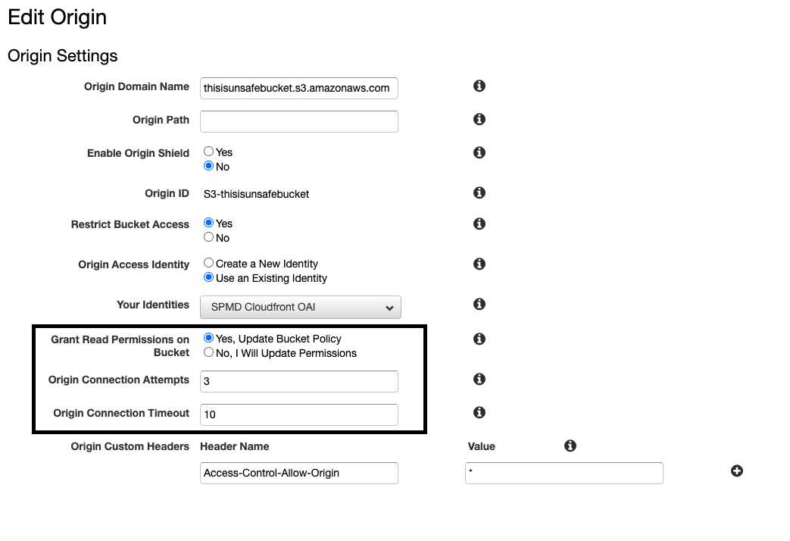

Finally click the Yes, edit button

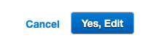

References:



[1]"Amazon S3 + Amazon CloudFront: A Match Made in the Cloud | Amazon Web Services", *Amazon Web Services*, 2020. [Online]. Available: https://aws.amazon.com/blogs/networking-and-content-delivery/amazon-s3-amazon-cloudfront-a-match-made-in-the-cloud/#:~:text=By%20caching%20your%20content%20in,users%20when%20they%20request%20content. [Accessed: 11- Nov- 2020].